Notes from Segel’s Enzyme Kinetics (c. 1975)
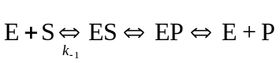
Enzymes (E) bind to their substrate (S) to form a complex (ES) which is then converted to a product (EP) which is released from the enzyme (P).
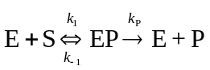
An assumption can be made that the rate at which ES dissociates to E and to S is much faster than the rate at which ES forms EP. Moreover, it will be assumed that the presence of EP is insignificant, meaning that E does not form a complex with product. An additional assumption is that the amount of S present is much larger than the amount of enzyme. Also an assumption is made that there is no product present, so the reverse reaction is insignificant.
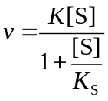
From this, the form of the Henri equation can be given:
Since we know that the total amount of enzyme (Et) is present as both free enzyme (E) and bound form (ES), and since the rate of product formation is directly dependent upon the amount of ES present, the following statements are valid:
[Et] = [E] + [ES]
v = kP [ES]

Notes from:
Kent M. Plowman, Enzyme Kinetics, (New York: McGraw-Hill), 1972.

Introduction
A coenzyme is always a substrate unless bound as a prosthetic group; it is a specialized type of substrate...regenerated by other enzymic reactions to complete a cycle and permit repeated use. A cofactor refers to all essential nonenyzmic components of the reaction other than the substrate of interest, and is intended to refer to metal ions, loosely bound prosthetic groups, catalytic intermediates. A prosthetic group is a tightly bound molecular structure of nonprotein origin used in the catalysis; if the group is altered during catalysis, its regeneration to ready form is done within the confines or is another function of the enzymatic action.
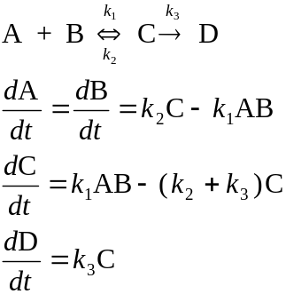
In understanding a series of chemical reactions, rate equations should be written for each step to define the changes in species, with assumptions being made later. Consider the following two reactions (one reversible):
In analyzing this particular set of reactions, we may explore several possibilities:
(1) if k2 is larger than k3, then species C will come to equilibrium with A and B quickly, in which first order conversion from C to D is the case
(2) if k2 ≈ k3 or even smaller, A and B are quickly coverted to C, with a first-order conversion of C to D. But if k3 >> than k1A, k1B, and k2, a second-order conversion from A and B to C is observed.
All equations are solvable for the four unknowns A, B, C, and D, if a fourth equation is furnished, namely a mass conservation equation being A–B=A0–B0 (the initial concentrations of A and B must be known).

Catalyzed Reactions
Suppose we look at the form of the last reaction and substitute certain letters to stand for certain concepts.
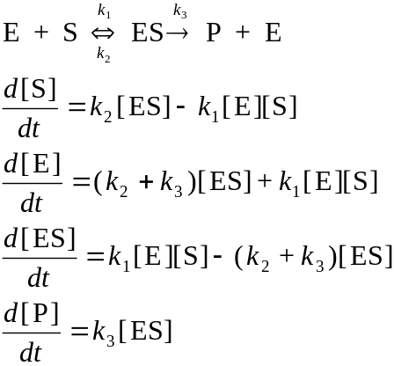
Since the enzyme E is conserved throughout the reaction, we would put a conservation equation in that [E]t = [E] + [ES], thus solving the equations. However, the solutions which would plot the change in concentration of each component over time are complex.
In most catalyzed reactions, the amount of enzyme to substrate (E/S) is quite small in unimolecular reactions. If the conversion of ES to P is quite slow relative to the reaction in which ES comes into equilibrium with E and S, then we can make an assumption that the [ES] during the extent of the reaction does not vary at all during time, i.e., d[ES]/dt ≈ 0. The following set of equations show the solution of the velocity of catalyzed reactions, a formula known as the enzyme velocity equation.
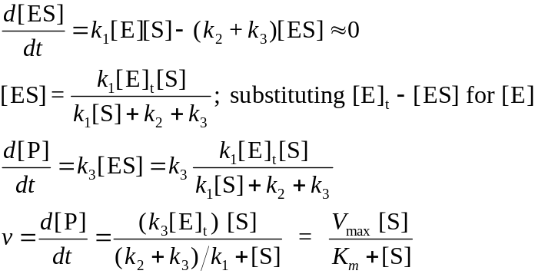
Note that in the equation Vmax depends upon the total enzyme present and is actually representative of the turnover number. Km is a combination of the rate constants. A rectangular hyperbola is seen on graphs of velocity vs. substrate concentration. At 0.5 Vmax, [S]= Km.
The reciprocal of the equation can be taken and rearranged to produce a linear form of 1/v vs. 1/[S], which forms a Lineweaver-Burk plot. In another rearrangement, v vs. v/[S] can be plotted in the Hofstee/Eadie plot. And in another rearrangement of the Lineweaver-Burk, in which the equation is multiplied by [S], the Hanes plot with [S]/v vs. [S] may be plotted with a slope of 1/Vmax
Solving for concentrations during a time course
First-order and its solution
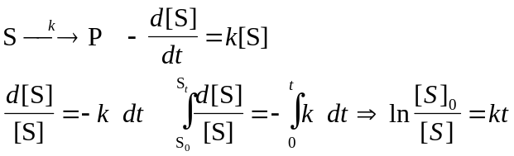:
(Bimolecular, one reactant) second-order and its solution
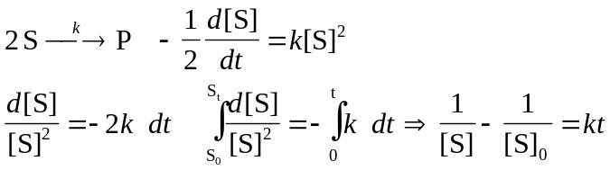
For the bimolecular reaction A + B → P, the solution is not so straightforward:
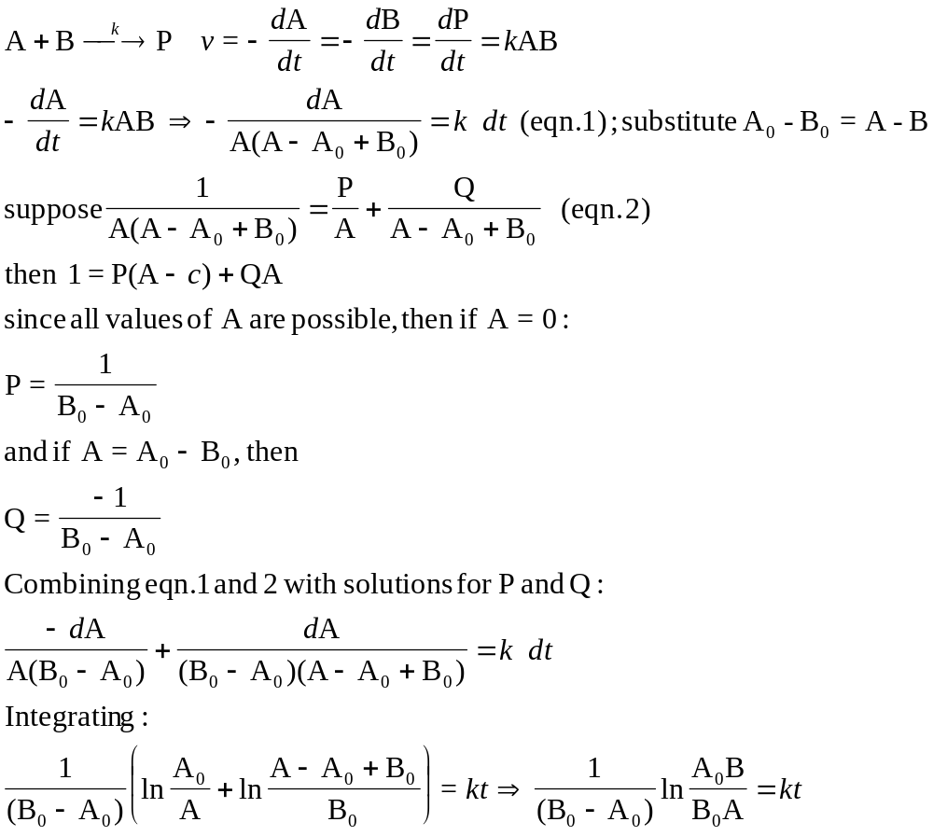
Suppose we consider that the intermediate ES is actually in equilibrium with the product P rather than merely an irreversible reaction. The solution for v then has both a forward and backward component. The rate equations will be defined with the conservation equation, the appropriate substitutions made and the final form will evolve.
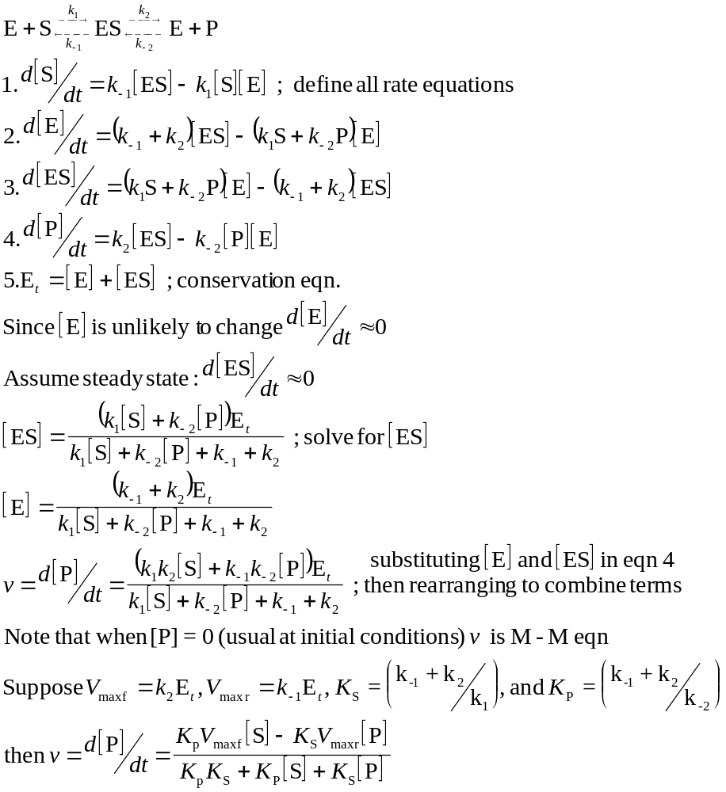

Notes from:
Nicholas C. Price and Lewis Stevens, Fundamentals of Enzymology, (New York: Oxford Univ. Press), 1982.

One Substrate Reactions

Theoretical background
The general description of an enzyme substrate interaction leading to the formation of an intermediate complex which goes on to make product is:
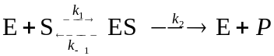
The rate of product formation is described by

Since this is the rate at which the enzyme works to make product in our system, it is necessary to determine what [ES] is in more experimentally known variables. To solve this type of problem, two types of assumptions may be used to derive the rate equations describing the kinetics:

1. The equilibrium assumption
Assume that E + S ↔ ES is at equilibrium and is only slightly disturbed by the breakdown of ES. Here we assume that k2 is insignificant compared to k-1. The equilibrium constant, K, is defined:

We must also declare that nearly all of the substrate is unbound compared to the bound form. So total substrate, [S]t, which is described as = [ES] + [S], is actually just [S], since [S]>>[ES]. The total enzyme similarly is [E]t = [E] + [ES]. In the following set of equations, we replace the term for [E] defined in the equilibrium constant using the total enzyme equation, rearrange to solve for [ES], then incorporate this solution for [ES] in the rate equation.
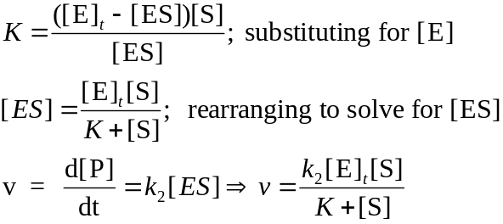
Note that K in this case is the equilibrium (dissociation) constant for ES.

2. The steady-state assumption
A better assumption is the one where k2 is significant relative to k-1, since it mimics what enzyme behavior is really like. If we plot [ES] against time during the reaction, there is a period in which is climbs quickly to a point and then drops down slowly but essentially remains steady in its concentration. Steady-state assumptions are only possible when d[ES]/dt << d[S]/dt or d[P]/dt, which is true under most conditions where [E]t << [S]t. In the following equations, k2 now becomes significant in the breakdown of ES, so the solution is more complex.
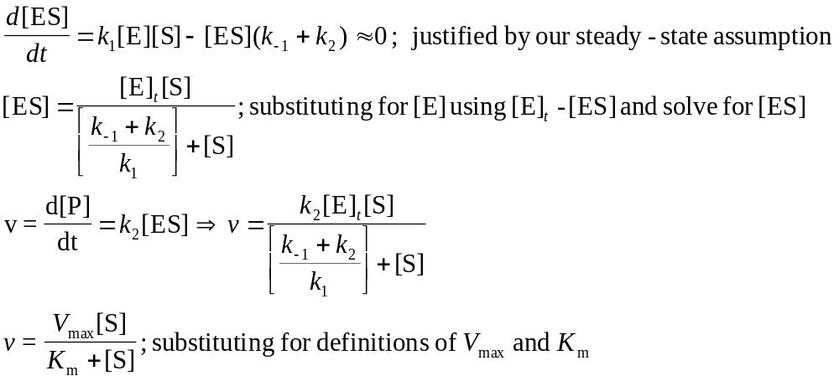
Note the difference here is that the Km constant is not the same as the dissociation constant for ES.

Plotting kinetic data
Lineweaver-Burk oldest and most used, but can be graphically poor when showing the experimental error. The Eadie-Hofstee plot is useful in for showing the error, but the Hanes plot is much better.
References
L. Michealis, M. L. Menten, Biochem. Z. 49, 333 (1913)
V. Henri, Lois generales de l’action des diastases, Hermann, Paris (1903)

Demonstration of Hill coefficient effects
v/Vmax |  |  | Km | [S]
n=0.5 | n=1 | n=2 | (µM) | (µM) | [S]/Km
0.969 | 0.99 | 0.999 | 0.1 | 10 | 100
0.957 | 0.98 | 0.99602 | 0.1 | 5 | 50
0.941 | 0.962 | 0.98425 | 0.1 | 2.5 | 25
0.934 | 0.952 | 0.97561 | 0.1 | 2 | 20
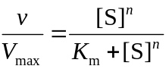
0.909 | 0.909 | 0.90909 | 0.1 | 1 | 10
0.876 | 0.833 | 0.71429 | 0.1 | 0.5 | 5
0.87 | 0.818 | 0.66942 | 0.1 | 0.45 | 4.5
0.863 | 0.8 | 0.61538 | 0.1 | 0.4 | 4
0.855 | 0.778 | 0.55056 | 0.1 | 0.35 | 3.5
0.846 | 0.75 | 0.47368 | 0.1 | 0.3 | 3
0.833 | 0.714 | 0.38462 | 0.1 | 0.25 | 2.5
0.817 | 0.667 | 0.28571 | 0.1 | 0.2 | 2
0.795 | 0.6 | 0.18367 | 0.1 | 0.15 | 1.5
0.76 | 0.5 | 0.09091 | 0.1 | 0.1 | 1
0.733 | 0.429 | 0.05325 | 0.1 | 0.075 | 0.75
0.691 | 0.333 | 0.02439 | 0.1 | 0.05 | 0.5
0.613 | 0.2 | 0.00621 | 0.1 | 0.025 | 0.25
0.5 | 0.091 | 0.001 | 0.1 | 0.01 | 0.1
0.414 | 0.048 | 0.00025 | 0.1 | 0.005 | 0.05
0.333 | 0.024 | 6.2E-05 | 0.1 | 0.0025 | 0.025
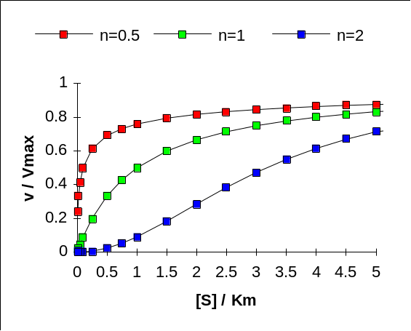
0.24 | 0.01 | 1E-05 | 0.1 | 0.001 | 0.01

